|  |  |
| --- | --- |
|  | **AMERICAN INTERNATIONAL UNIVERSITY-BANGLADESH (AIUB)**  Faculty of Engineering  Department of EEE and CoE  Undergraduate Program |







|  |  |
| --- | --- |
| **Course: Data Communication** | **Fall 2021-22, FINAL** |

**Experiment 6: Study of Amplitude Modulation and Demodulation using Simulink.**

**Submitted by:**

|  |  |  |
| --- | --- | --- |
| **Name** | **ID** | **Contact Details** |
| ASIF SHARIF AKASH | 20-42647-1 | 20-42647-1@student.aiub.edu |

**Section**: F



**Submitted To**

**AFSAH SHARMIN**

Lecturer

Faculty of Engineering   
American International University-Bangladesh

**Block Diagram**

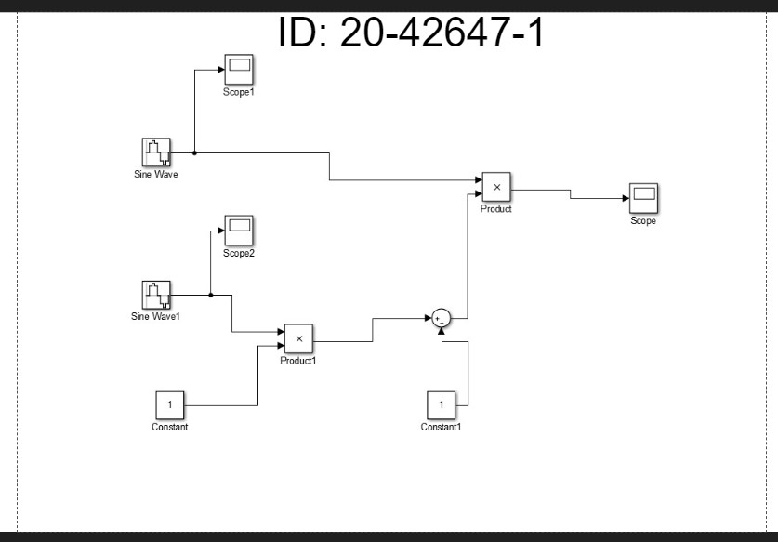

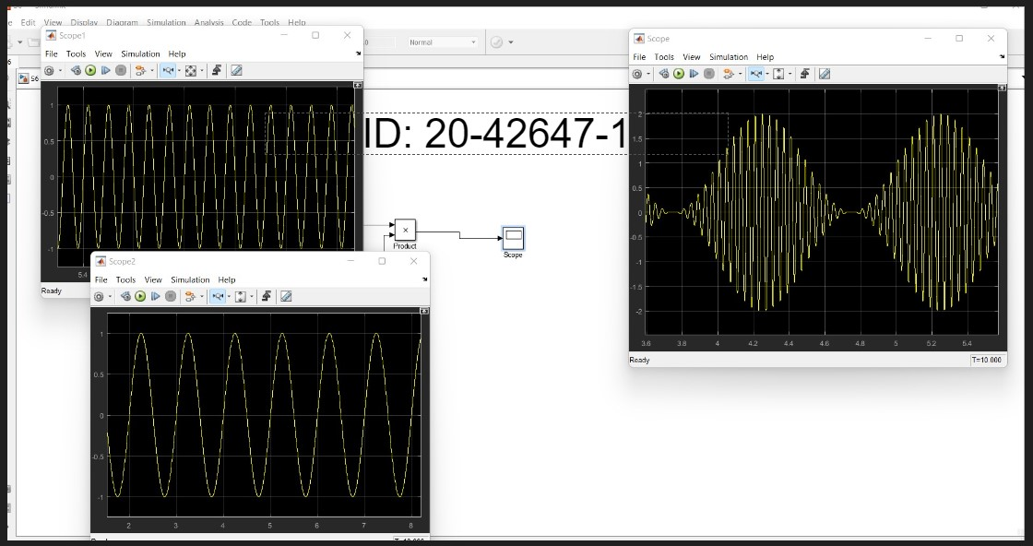

**Performance Task**

